# Prio 1. open a GUI main window

Run RobotShop application:

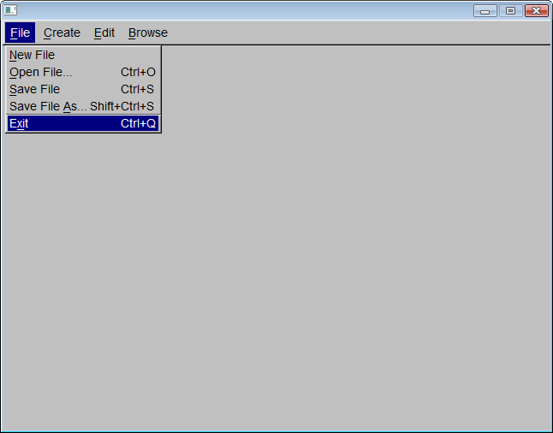

# Prio 2. create robot parts

Click **New File** under **File** menu item.

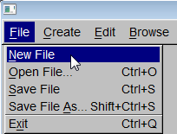

The system creates robot parts:

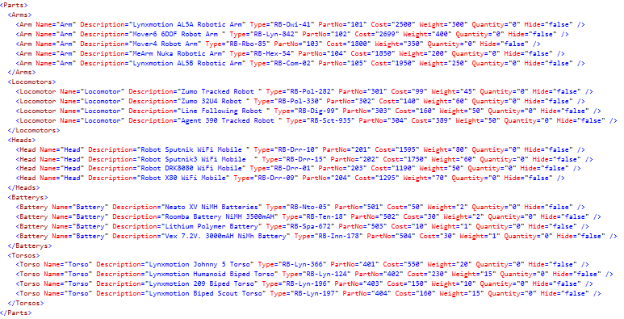

# Prio 3. create robot parts via GUI dialogs

Click **Robot Part** under **Create** menu item.

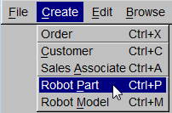

Fill out part information:

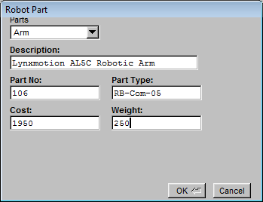

Click OK button. The system creates the part.

# Prio 4. define new robot models

Click **New File** under **File** menu item.



The system creates 4 robot models.

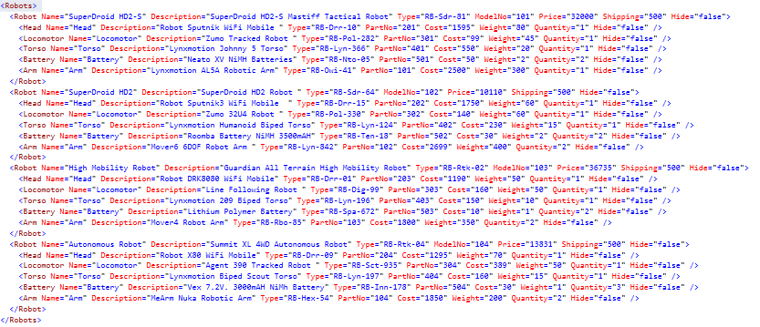

# Prio 5. define new robot models via GUI dialogs

Create **Robot Model** under **Create** menu item.

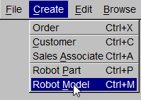

Fill out robot information

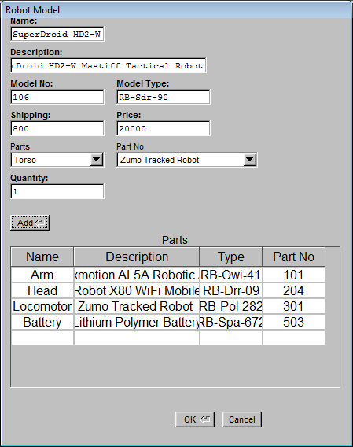

Click OK button to create the robot.

# Prio 6. browse a catalog of robots

Click Save File As under File menu item.

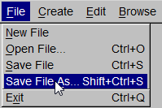

Type in a file name and click Save button.

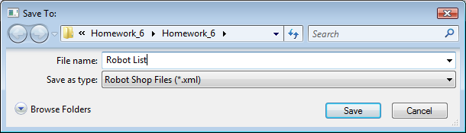

The system save the robot list with their parts to the file

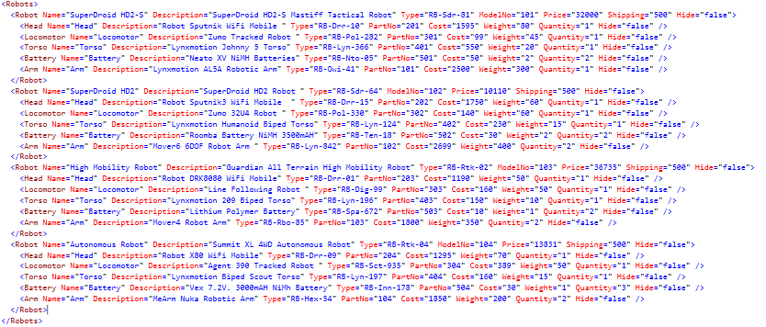

# Prio 7. browse a catalog of robots via a GUI report

Click Browse Catalog under Browse menu item.

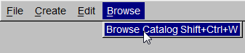

Select a robot model, the system display the robot information.

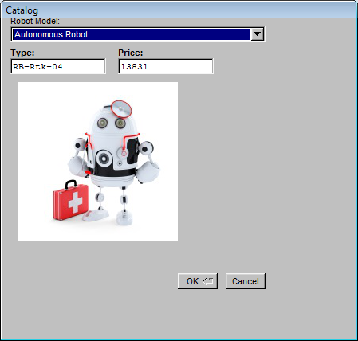

# Prio 8. see pictures of the robots in the GUI catalog

Click Browse Catalog under Browse menu item.



Select a robot model, the system display the robot picture.



# Prio 9. create a robot order for a Customer

Click **New File** under **File** menu item.



The system creates 2 customers:



# Prio 10. Create a new Beloved Customer via GUI

Click Customer under Create menu item.

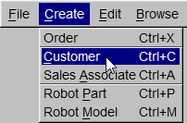

Fill in the customer name and click OK button.

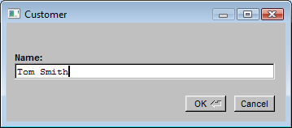

The system create the customer.

<Customer Name="Tom Smith" />

# Prio 11. Create a new Sales Associate via GUI

Click Sales Associate under Create menu item

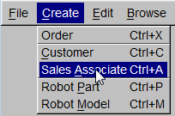

Fill in sales associate name and click OK button.

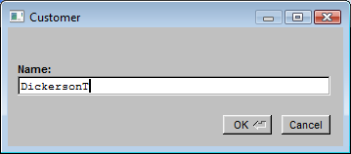

The system created the sales associate:

<SalesAssoc Name="DickersonT" />

# Prio 12. Create a robot order for a Customer via GUI

Click Order under Create menu item.

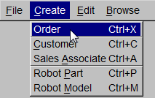

Fill in order information and click OK button.

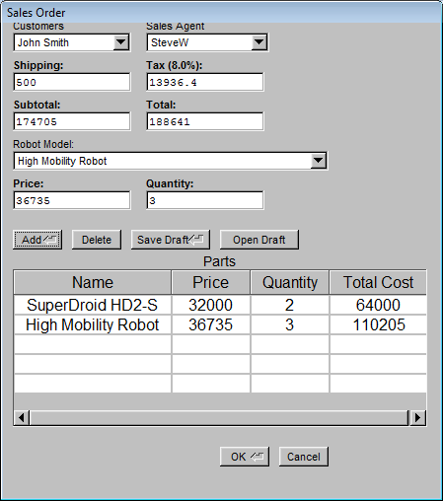

The system creates the order.

# Prio 13. ensure persistence of the RRS data

The system provides save/open robot shop data to xml files.

# Prio 14. allow the users to save data explicitly via GUI

Click Save File under File menu item.

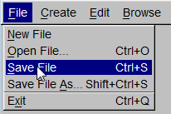

The system saves the robot shop data to the file.

# Prio 15. allow the users to load data explicitly via GUI

Click Open File under File menu item.

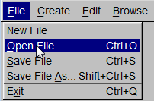

Select a file and click Open button.

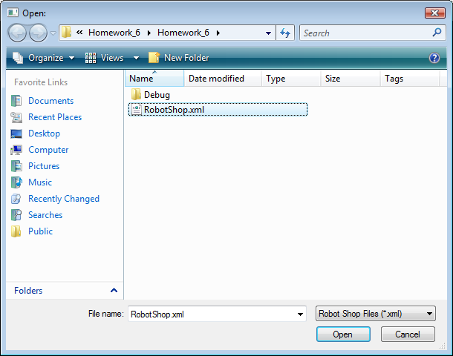

The system load the robot shop data in the file.

# Prio 16. allow the users to save data to a specified name via GUI

Click Save File As under File menu item.

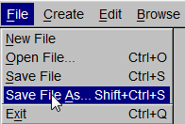

Type in a file name and click Save button.

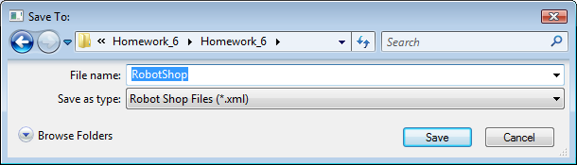

The system save the robot shop data to the selected file.

# Prio 31. create a bulk (2+) order for Customer via GUI

Click Order under Create menu item.



Fill in order information and click OK button.



Click Add button to add multiple robots to the order.

# Prio 32. hide robot parts via GUI

Click Hide Robot Part under Edit menu item.

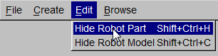

Select a robot part and click the Hide Part checkbox.

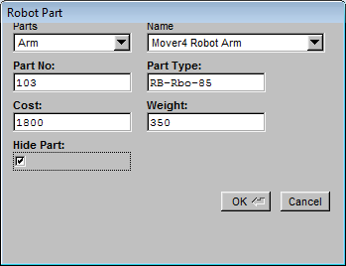

The system hide the robot part from the selection in define Robot Model screen.

# Prio 33. hide robot models via GUI

Click Hide Robot Model under Edit menu item.

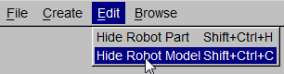

Select a robot model and click the Hide Robot Model checkbox.

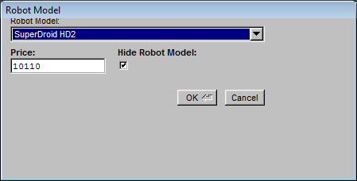

The system hides the robot model from selection in Order screen.

# Prio 34. save a draft order and return to it later via GUI

Click Order under Create menu item.



Fill in order information and click OK button.



Click Save Draft button to save the draft order and create Open Draft button to open the saved draft order .